|  |
| --- |
| https://uwaterloo.ca/brand-guidelines/sites/ca.brand-guidelines/files/resize/uploads/images/universityofwaterloo_logo_vert_rgb_0-300x195.png  FACULTY OF ENGINEERING |
| **Design of Spectaculum Lautus “Eyeglasses Cleaning Robot”** |
| A report prepared for Final Mechatronics 100 Project |
|  |
| by  Siddhant Chandgadkar, Rimpey Diaz, Brandon Fong, Himel Mondal  1A Mechatronics Engineering |
| 11/16/2015 |

**Table of Contents**

List of Figures 2

List of Tables 3

1.0 Introduction and Background 4

1.1 Design Problem Definition 4

1.2 Goals and Objectives 4

2.0 Design Criteria and Constraints 4

2.1 Constraints 4

2.2 Criteria 4

3.0 Mechanical Design and Evaluation 5

3.1 Design A 5

3.2 Design B 6

3.3 Design C 6

3.4 Design D 6

3.5 Overall Design Evaluation Comparison 7

3.5.1 Evaluation of Constraints 7

3.5.2 Evaluation of Criteria 7

3.5.3 Conclusion of Design Evaluation Comparison 8

4.0 Task List 8

5.0 Project Plan: Gantt Chart 8

6.0 References 9

# **List of Figures**

Figure 1: Design A, Figure 2: Design B 5

Figure 3: Design C, Figure 4: Design D 5

Figure 5: Gantt Chart of Final Project Planning 8

# **List of Tables**

Table 1: Ratings of Design with Numerical Values 7

Table 2: Constraints of Design Evaluated with Numerical Values 7

Table 3: Criteria of Design Evaluated with Numerical Values 7

# **1.0 Introduction and Background**

    Spectaculum Lautus is a smart eyeglass cleaning robot that detects the area of the lenses using light intensity sensors on the frame around the glasses to autonomously develop an optimal path to clean the entirety of the surface.

## **1.1 Design Problem Definition**

    Glass surfaces are embedded in many products used every day by large masses of people. These surfaces are found on products such as eyeglasses and screen technologies like smartphones. The rate at which these screens are smudged and get dirty is very high as dust and oil on fingers easily affect these glass surfaces. Manually cleaning these products constantly is a very meticulous process that isn’t always effective on the first iteration. The struggle of cleaning eyeglasses is a real one and should be addressed in modern society, as glasses have been a fundamental part of human vision clarity for centuries.

## **1.2 Goals and Objectives**

    The fundamental goal of this project is to be able to successfully clean both glass surfaces of a pair of eyeglasses without the aid of any human. The final result of this goal is that a smudged pair of eyeglasses will be absolutely clear. To polish this project, other objectives such as being able to mechanically spray the surface of the glasses, detect the bounds of the eyeglasses, and successfully flip the glasses to clean both sides of the lens are being thoroughly pursued as they can be seen as relevant and attainable features to this project.

# **2.0 Design Criteria and Constraints**

## **2.1 Constraints**

   The purpose of the eyeglasses cleaning robot is to provide clean lenses, which enhance the clarity and vision of a user.  There are four constraints for this objective to be met.  Firstly, the robot must detect a given pair of glasses.  This constraint will be met using sensor technology equipped on the robot.

Secondly, the glasses cleaning utensils must reach the lenses.  The robot is not useful if the utensils are not making contact with the lenses.

Thirdly, the cleaning utensils must make contact with the lenses without breaking them.  The glasses must be kept intact throughout the whole cleaning process.

Finally, the utensils must maintain contact with the glasses as it traverses the surface of the lenses. Smooth contact with the lenses will result in a cleaner finish.

## **2.2 Criteria**

          Once the robot has met the requirements dictated by the constraints, there are four criteria this robot can satisfy to improve the user satisfaction.  The first criterion is that the spraying mechanism sprays the glasses accurately.  This would make it much easier for the utensil to move across the surface of the lenses, since there would be less frictional contact with the lenses (resulting in a cleaner finish).

The second criterion identified is that the entirety of the lenses are cleaned.  This is different from the constraint, as it is focused more on cleaning the edges of the lenses, which is more difficult than solely the area through which the user views most of what is in front of him / her.

A third criterion is to include a cleaning pattern that fits the shape of the glasses.  Eyeglasses come in a variety of shapes, from rectangular to elliptical shapes.  Thus, if the same circular cleaning pattern is applied to all the pairs of glasses being cleaned, then one user may have a significantly better experience with the robot than the other.

The final criterion proposed is to mechanically ‘flip’ the glasses so both sides of the lenses can be cleaned.  Since vision is affected by both sides of the lenses, it would be useful to a user to have two clean sides to a lens, rather than one.

# C:\Users\Siddhant Chandgadkar\OneDrive\Year 1 Mechatronics\Mechatronics - MTE 100\MTE Final Project\Rough Design Sketch - MTE 100.jpg**3.0 Mechanical Design and Evaluation**

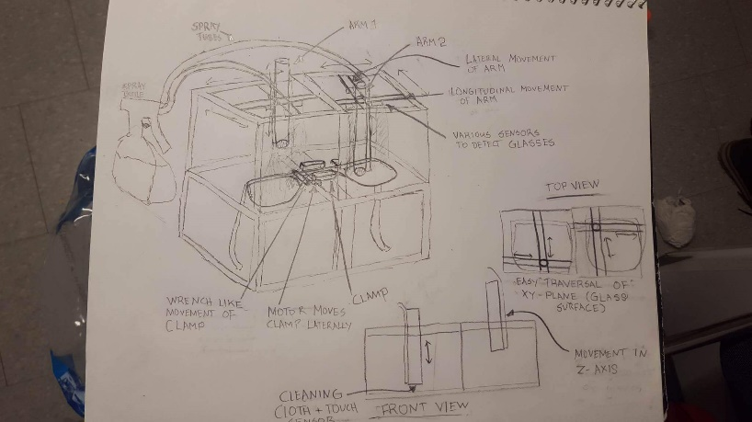

**Figure 1: Design A Figure 2: Design B**

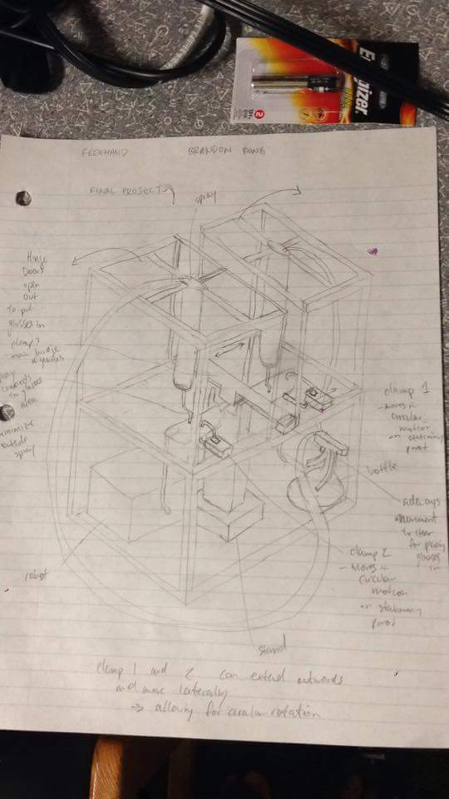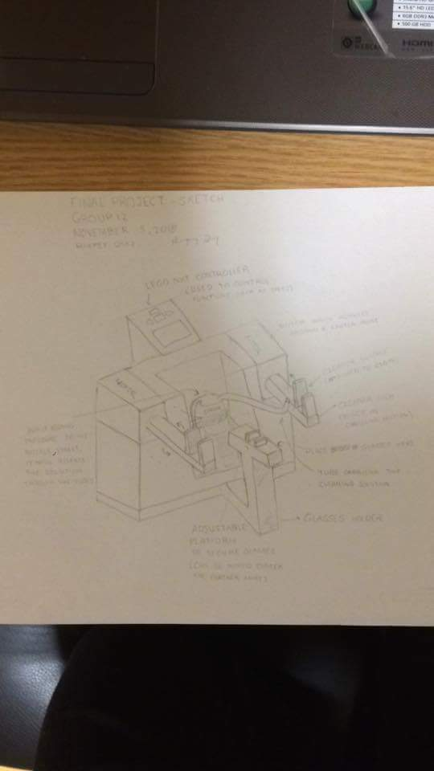

**Figure 3: Design C**  **Figure 4: Design D**

## **3.1 Design A**

This design incorporates its own variant among each criteria given in this project. The rectangular prism designed structure of this robot allows for traversal of the surface plane of the glasses as all of the components of robot are on the same vertical axis.

To detect the glasses, the sensors are to be mounted in line with the movement of the cleaning arm so that it may always be able to detect the glasses with the arm to carry out its function.

Tubes that connect to a spray bottle will be connected to the head of the cleaners to easily spray directly on the surface of the glasses. The downside of using these tubes is that they may not spray a ‘mist’ of cleaner as the right type of tubing may not be found.

    It is highly likely that this design will do a good job in cleaning the surfaces of the glasses within its frame as there are three means of sensing. The touch and ultrasonic sensors together detect if the arm is touching the glasses and the light intensity detects its bounds.

    Flipping the glasses in this design is very poorly expressed as it is not feasible to rotate the glasses on how it is resting on the clamp in the middle of the design.

## **3.2 Design B**

Design B adds some of its own unique characteristics. In terms of achieving the constraints set forth, the glasses can be detected to start the function of the robot with a touch sensor placed between the manual clamp and the block to place the glasses. However, pressure between a clamp, a block and a touch sensor may be a poor solution, since this could damage or break the bridge of the glasses.

Secondly, the circular cleaners can make contact with the lenses without breaking them off; however, if the bridge of the glasses are under pressure, it could result in the bridge breaking, which could break the lenses if the glasses were to fall. Thus, this is an adequate solution to the constraint.

With regards to the criteria of the project, the first criterion that the glasses are sprayed accurately is dependent upon how the motor positions the spray cart on the track. This can be considered a good solution, since motor encoder values will allow for a good approximation of this position.

The third criterion of cleaning based on lens shapes is met through coding the motor, which will allow for a circular motion of the cleaning utensils, covering more area, thus resulting in a better finish.

## **3.3 Design C**

      From the alternative design in figure C, having three arms to perform the needed functions, it is able to hold the glasses with the arm in the middle. With the implementation of a sensor in it, it can detect when the glasses are placed in the arm itself.

Both arms on each side of the robot are able to surround the glass area. Having two cloths in each clamp, it is able to make contact with the glasses itself. Using the motors, the arms are able to be moved in circular motion to wipe the glasses clean.

Based on the criteria stated, even though the design provided is not able to flip the glasses as required, it is not needed since both the right and left arm are able to clean both ends of the glasses.

This design is not able to adjust the cleaning pattern based on the shape of the glass since it would be constantly moving the same direction and in a circular motion, although the size and shape of the glasses can be detected with the use of an ultrasonic sensor at the end of each arm.

## **3.4 Design D**

This alternative mechanical design utilizes ultrasonic sensors at the tip of the spraying arms to detect where the glasses are so that it can move towards the location. However, it is tough to carry out as the sensor may interfere with the function of the spray tube.

The arms used to clean the lenses are also very delicate so as not to break the glasses when making contact with its surface. The size of the cleaning arm also ensures that movement will not be fast enough to damage the lenses in case it moves erratically.

    The spray of cleaning fluid is quite accurate because of the tube that descends from the spray canister mounted on top of either lens. This allows for more control of the direction of the fluid so that none is being wasted and that every part of the lens can be reached.

A mechanical clamp placed on a centered stand can flip the glasses in the opposite direction to allow the other side of the lenses to be cleaned, but may pose a challenge because the rectangular structure may get in the way and the clamp is not situated in a sturdy position.

## **3.5 Overall Design Evaluation Comparison**

All the designs were evaluated on a scale as follows, according to the set criteria and constraints:

**Table 1: Ratings of Design with Numerical Values**

|  |  |
| --- | --- |
| **Rating** | **Numerical Rating** |
| Excellent | 1.0 |
| Good | 0.6 |
| Adequate | 0.3 |
| Poor | 0.1 |

### **3.5.1 Evaluation of Constraints**

**Table 2: Constraints of Design Evaluated with Numerical Values**

|  |  |  |  |  |
| --- | --- | --- | --- | --- |
| **Constraints** | **Design A** | **Design B** | **Design C** | **Design D** |
| Ability to Detect pair of glasses | 1.0 | 1.0 | 0.6 | 0.3 |
| Ability to reach and make contact with glasses | 0.6 | 0.6 | 1.0 | 0.3 |
| Ability to safely clean glasses without breaking | 0.6 | 0.6 | 0.3 | 0.3 |
| Ability to maintain contact with glasses in a smooth path | 0.3 | 0.3 | 0.3 | 0.6 |

### **3.5.2 Evaluation of Criteria**

**Table 3: Criteria of Design Evaluated with Numerical Values**

|  |  |  |  |  |
| --- | --- | --- | --- | --- |
| **Criteria** | **Design A** | **Design B** | **Design C** | **Design D** |
| Ability to spray entirety of Glasses (accuracy) | 0.3 | 0.6 | 0.6 | 0.6 |
| Ability to Clean entirety of glasses (effective) | 1.0 | 1.0 | 0.6 | 0.3 |
| Ability to easily sense pattern to clean glasses | 1.0 | 0.3 | 0.3 | 0.3 |
| Ability to successfully rotate the glasses about an axis | 0.1 | 0.1 | 0.1 | 0.1 |

### **3.5.3 Conclusion of Design Evaluation Comparison**

Considering the top qualities of each constraint and criteria of each design proposed in the group, the best aspects of each design will all be incorporated together. While maintaining the tower-like design initially proposed among the majority of designs, various integrations of this design have changed in conception. This applies to various micro changes to main design.

# **4.0 Task List**

Once the glasses are placed on the clamp of the robot, it will begin to detect the distance away from the glasses and calibrate the arm to be positioned in the middle of the glasses by detecting the bounds of the glasses using a light intensity sensor. A mechanism for causing the bottle to spray will activate and spray the surface of the glasses. The robotic cleaning arms will lower until the ultrasonic sensor has detected that the arms are close enough to the sensor. To verify that the arms are touching, a touch sensor mounted in the middle of the two arms will continue to lower until it touches the bridge of the glasses. A calculated path of movement of the arms will take place until the light intensity sensors sense the frame of the glasses, where the extents of the glass surface will be reached. This will effectively clean the front side of the glasses. The arms will move up to a safe location where it started initially. The glasses will rotate 180 degrees so that the other side of the glasses will be exposed. The process of cleaning is then repeated.

# **5.0 Project Plan: Gantt Chart**

**Figure 5: Gantt Chart of Final Project Planning**

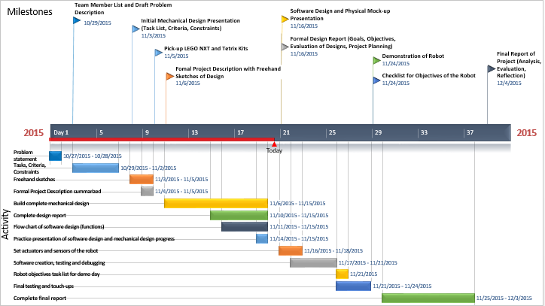

# **6.0 References**

[1] ‘Critical Path Analysis and PERT Charts’, *Mindtools Editorial Team*. [Online]. Available: <https://www.mindtools.com/critpath.html>. [Accessed: 13-Nov-2015].

[2] ‘Project Planning’, *MTE 100*. [Online]. Available: <https://learn.uwaterloo.ca/d2l/le/content/219749/viewContent/1279852/View?ou=219749>. [Accessed : 13-Nov-2015].

[3] ‘Eyewear Frame Anatomy’, *Ecofocals*. [Online]. Available: <http://ecofocals.com/pages/glasses-anatomy>. [Accessed : 11-Nov-2015].